Logical func. and Lookup

- Write a formula to check if the marks in cell are greater than or equal to 40. If yes, return “Pass”, otherwise “Fail”.
Student Name | Marks
Riya | 45
Rahul | 80
Raju | 55
Siya | 72
Ram | 30

- =IF(B2>=40, “Pass”, “Fail”)
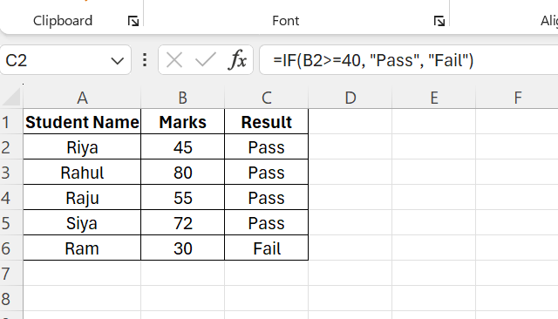

- A company gives a bonus if sales are above 40,000 and attendance is greater than or equal to 90%. Write a formula to calculate whether the employee will get a bonus or not.
Employee | Sales | Attendance
Arjun | 55000 | 95
Simran | 65000 | 85
Rohit | 30000 | 90
Anjali | 25000 | 65

- =IF(XOR(B2>40000, C2>=90), “BONUS”, “NO BONUS”)
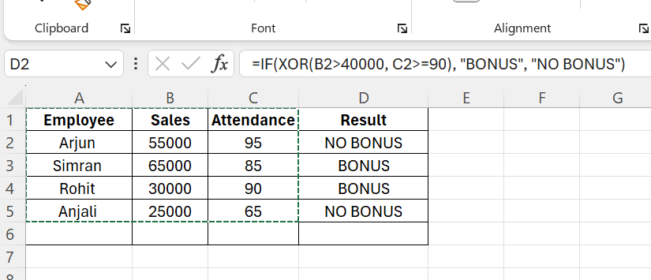

- Write a nested IF formula:
If marks in B2 are ≥ 90 → "A", ≥ 75 → "B", ≥ 50 → "C", otherwise "Fail".
Student's Name | Marks
Raj | 85
Neha | 96
Vivek | 57
Rani | 92
Sneha | 75

- =IFS(B2>=90, “A”, B2>=75, “B”, B2>=50, “C”, B2<50, “Fail”)
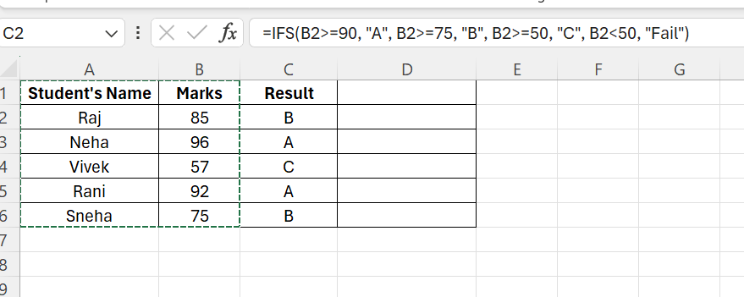

- Find the Department of Employee ID = E103. Also explain which LOOKUP function is used and why?
Emp ID | Name | Department
E101 | Raju | It
E102 | Riya | HR
E103 | Roshni | Finance
E104 | Sejal | Sales

- XLOOKUP is used because it can search for value from one column and return a result from another column, it is more flexible and gives exact match by default. We could have used Vlookup also but Xlookup is more simple.
- =XLOOKUP(“E103”,A1:A5, C1:C5)

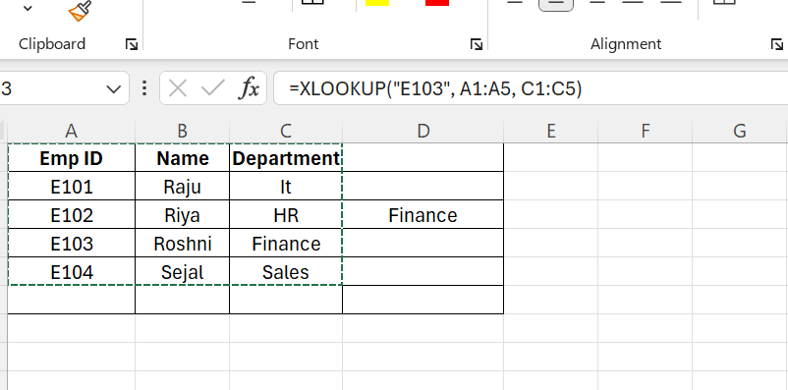
- A company has set the following commission structure for its sales team.
Sales Amount | Commission Rate
0 | 5%
20000 | 10%
50000 | 15%
80000 | 20%

If a salesperson achieves sales of ₹45,000, use the VLOOKUP function to determine the commission rate applicable.

- =VLOOKUP(45000,$A$2:$B$5, 2, TRUE)

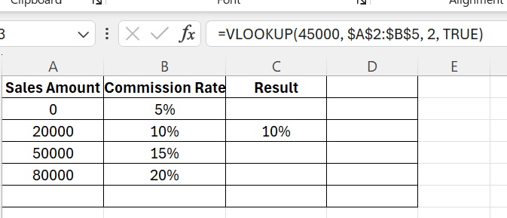

- The HR department maintains the following leave records of employees:onus or not.
Employees Name | Leaves Taken | Leaves Allowed
Alex | 10 | 12
Bob | 10 | 15
Anna | 8 | 12

Write an IF function to check whether an employee has Exceeded their allowed leave balance. If Leaves Taken > Allowed Leaves, display "Exceeded".
Otherwise, display "OK".

- For an example, added one more name to understand better.
- =IF(B2>C2, “Exceeded”, “OK”)

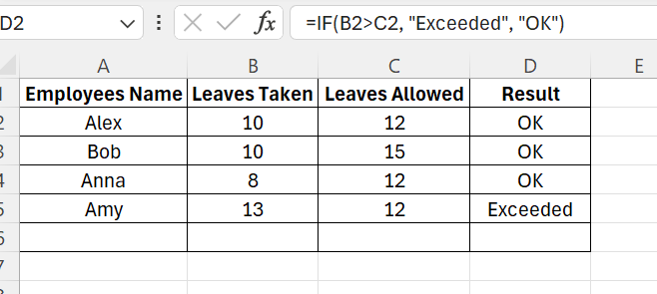

- Find the salary of EmpID = E105 using INDEX-MATCH Function.
EmpID | Salary
E104 | 55000
E105 | 72000
E106 | 62000
E102 | 41000

- =INDEX(B1:B4, MATCH("E105", A1:A4, 0))

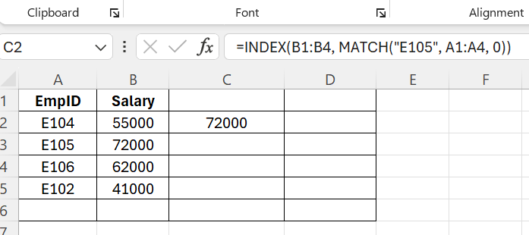

- Use the XLOOKUP function to find the Department of the employee with Emp ID = E303.
EmpID | Department
E101 | HR
E303 | IT
E106 | Sales
E301 | Finance

- =XLOOKUP(“E303”, A1:A5, B1:B5)

